**Counterfeiting Detection System: A Solution to Combat Product Counterfeiting**

**ABSTRACT**

Counterfeiting is a severe economic and social issue, affecting both industries and the global market. The illicit trade in counterfeit brands poses a significant threat to the world economy, hindering the growth of brands in India and worldwide.

Fraudulent activities related to forgery and counterfeit products have surged across various industries in recent decades. This trend has left consumers struggling to differentiate genuine products from counterfeits. To combat this problem, a "Counterfeit Detection System" is proposed. This research paper explores the development and application of this system, focusing on its use in identifying counterfeit branded clothing.

The Counterfeit Detection System employs QR codes linked to a manufacturer's database. When consumers scan a QR code, the system validates the product's authenticity and alerts if the product has been sold before. This system enhances consumer trust, protects manufacturers, and ensures supply chain transparency.

While initially aimed at branded clothing, the system's principles can apply to various industries. This research paper emphasizes the importance of safeguarding consumers and businesses from counterfeit products in today's global marketplace.

**KEYWORDS**

Counterfeiting, Illicit trade, forgery, QR Code, authenticity validation, Global Marketplace.

**1. INTRODUCTION**

The Counterfeit Detection System is a vital web application designed to combat the pervasive issue of counterfeit clothing products. In a world where consumers often find themselves in a precarious position—uncertain whether the product they intend to purchase is genuine or a deceptive knockoff—this innovative solution emerges as a safeguard against fraud. The ramifications of unknowingly buying counterfeit goods are profound, leading to financial losses for consumers and tarnishing the reputation of authentic brands. For companies, the consequences include lost sales due to undercutting prices, erosion of brand integrity, strained relationships with business partners, and the need to allocate resources to combat counterfeiting.

Recognizing the urgency of this problem, the Counterfeit Detection System steps in to assist users in navigating this treacherous terrain. Its mission is clear: to empower consumers with the tools needed to make informed purchasing decisions and to eradicate counterfeit products from the marketplace. At its core, this web application leverages the innovative concept of QR code scanning, offering a seamless and efficient means of verifying product authenticity during the purchasing process.

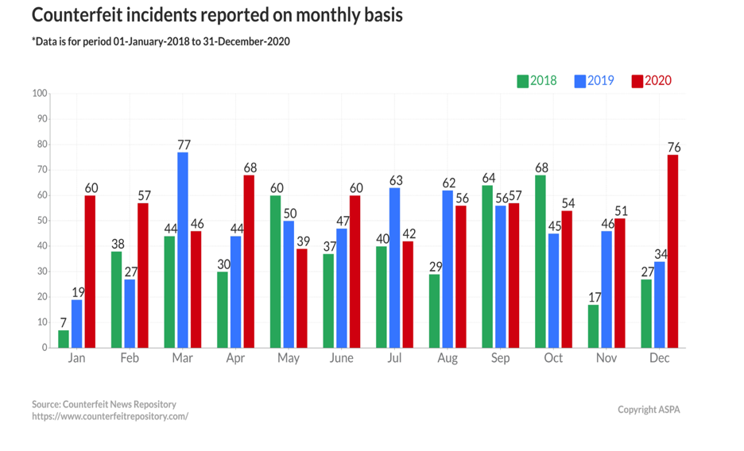

The Counterfeit Detection System is designed with a multi-faceted technological foundation, incorporating the prowess of Machine Learning, Front-End and Back-End web development, and a robust database. Machine Learning, a subset of Artificial Intelligence, plays a pivotal role in the system, enabling automated processes and decision-making without the need for manual human intervention.

On the web development front, React is harnessed for the Front-End, providing an intuitive and user-friendly interface that facilitates QR code scanning and the retrieval of product details. Meanwhile, Django powers the Back-End, managing the database, authentication, and the seamless flow of information.

In essence, the Counterfeit Detection System is not merely a web application; it is a beacon of hope for consumers and brands alike, illuminating a path toward a counterfeit-free shopping experience. It embodies the spirit of technological innovation harnessed for the greater good, safeguarding trust in commerce and ensuring that every purchase is a genuine one.

**2.1. LITERATURE REVIEW**

**1- Detection of Counterfeit Products Using Blockchain**

**Kunal Wasnik, Isha Sondawle, Rushikesh Wani and Namita Pulgam Ramrao**

**Adik Institute of Technology D Y Patil Deemed to be University Navi Mumbai**

The document titled "Detection of Counterfeit Products Using Blockchain" explores the integration of blockchain technology to combat counterfeit products in supply chains. It highlights the shortcomings of traditional methods like RFID tags and QR codes and proposes blockchain as a more effective solution. Blockchain ensures product traceability and security by recording transactions across multiple parties simultaneously, enhancing supply chain transparency.

The paper discusses the adverse impacts of counterfeit products on the economy and consumer safety, emphasizing the challenges faced by legitimate companies in managing customer dissatisfaction and preserving their reputation. It outlines the workings of blockchain, emphasizing its decentralized nature and robust security features, which prevent unauthorized data modifications.

In conclusion, the document underscores the potential of blockchain technology to enhance supply chain transparency and security in the fight against counterfeit products. By providing a comprehensive overview of blockchain's capabilities and its application in combating counterfeit goods, the paper advocates for its adoption as a reliable solution in the battle against product counterfeiting.

**2- A secured tag for implementation of traceability in textile and clothing supply chain**

**Tarun Kumar Agrawal & Ludovic Koehl & Christine Campagne**

The research paper titled "A secured tag for implementation of traceability in textile and clothing supply chain" delves into the deployment of a traceability system to tackle the challenges of opacity, insecurity, and untraceability prevalent in the textile and clothing industry supply chain. The study introduces a two-factor secured tag based on particle randomness, applied onto textile surfaces. These particles serve as unique identifiers, ensuring easy readability and validation while making the tags resistant to cloning, thus mitigating the risks of counterfeiting.

Within the context of industries vulnerable to counterfeiting, such as textiles and clothing, the paper underscores the criticality of supply chain transparency and security. It points out the industry's significant security lapses, leading to financial losses and safety concerns for consumers. To address these issues, the study advocates for a secured traceability system integrating a unique identifier tag with a random particle-based secured tag, with the objective of bolstering product authentication, traceability, and overall security.

Furthermore, the paper discusses the utility of barcodes, including linear barcodes and QR codes, as efficient and cost-effective means of product tracking in the supply chain. Unlike detachable RFID tags, barcodes are highlighted for their eco-friendliness, degradability, and lack of privacy concerns. The proposed system builds upon the advantages of barcodes and introduces an extra layer of security through the random particle-based secured tag. Experimental assessments have been conducted to assess the system's performance and verify its uniqueness, providing empirical support for its effectiveness in enhancing traceability and security in the textile and clothing supply chain.

**3- Title: A Network-based Approach to Counterfeit Detection**

**Supreeth Sathyanarayana, William H. Robinson, Raheem A. Beyah**

Counterfeit devices pose a significant threat to industries, causing billions of dollars in revenue loss. Existing counterfeit detection techniques are often complex, expensive, and slow, with limited applicability to specific devices. To address these limitations, this research paper proposes a novel network-based solution for counterfeit detection. By monitoring the network traffic of a device, the proposed technique offers a simple, inexpensive, and non-destructive approach to swiftly test a broad range of networked devices.

The paper demonstrates the effectiveness of the technique using field-programmable gate arrays (FPGAs) and real systems with different processors. It shows that the interarrival times (IATs) of network traffic can be used to differentiate lower-end processors from higher-end ones, even when components are counterfeited or re-marked as higher capacity. By employing a neural network-based classifier, the technique achieves recall values of up to 78.7% in detecting counterfeit components.

Compared to existing methods, the proposed network-based approach offers several advantages. It is cost-effective, fast, non-destructive, and has broader applicability. It does not require specialized hardware or complex setups. The technique can detect counterfeit components that are illegally re-marked as legitimate ones, addressing a significant concern in the industry. The research findings highlight the potential of network traffic analysis as a powerful tool in counterfeit detection, providing valuable insights for companies and governments combating counterfeiting threats.

Overall, this paper presents a pioneering network-based approach to counterfeit detection, offering a practical and efficient solution for identifying counterfeit devices. By leveraging network traffic monitoring and statistical analysis, the proposed technique demonstrates promising results in distinguishing between genuine and counterfeit components. Its simplicity, cost-effectiveness, and broad applicability make it an attractive option for companies and governments seeking effective measures against counterfeiting in the technology industry.

**4- IMPROVING FAKE PRODUCT DETECTION USING AI-BASED TECHNOLOGY Eduard Daoud, Dang Vu, Hung Nguyen and Martin Gaedke**

The research paper titled "Improving Fake Product Detection Using AI-Based Technology" focuses on the use of AI-based technology to combat counterfeiting. The paper highlights the growing problem of counterfeit products, with estimates of up to 1.2 trillion USD worth of counterfeited goods in 2017, and emphasizes the need for technological solutions to complement the efforts of inspection bodies and authorities. The goal is to involve end consumers in the detection process and enable them to contribute to the fight against product piracy.

The paper discusses various anti-counterfeiting technologies, including overt, covert, and track and trace methods. However, it acknowledges the limitations of these technologies, such as the ease of imitation and the requirement for special equipment. To address these challenges, the proposed solution relies on machine learning-based technology, particularly image and text recognition. By utilizing the built-in digital cameras and internet access of smartphones, end consumers can capture images of product packaging and send them to a server for processing and verification. The system then provides the detection results to the consumers, empowering them to make informed decisions.

Overall, the research paper introduces a low-cost and user-friendly approach to counterfeit product detection. It emphasizes the importance of involving end consumers in the process and leveraging AI-based technology to enhance detection capabilities. By combining image and text recognition with existing anti-counterfeiting technologies, the proposed system aims to improve the efficiency and effectiveness of counterfeit detection.

**5- Title: Recent Functional Material-Based Approaches to Prevent and Detect Counterfeiting**

**Bora Yoon, Jung Lee, In Sung Park, Seongho Jeon, Joosub Leea and Jong-Man Kim**

This research paper discusses recent advancements in functional material-based approaches for preventing and detecting counterfeiting. With the rise of sophisticated counterfeit products due to technological advancements, there is a growing need for innovative anti-counterfeiting materials and systems. The paper focuses on colorimetric and fluorometric methods used to determine the authenticity of banknotes, documents, and medicine. It also explores the incorporation of organic electronics and molecular imaging techniques for counterfeiting detection.

Counterfeiting poses significant economic and social problems, infringing upon copyright owners' rights and jeopardizing public health. Traditional anti-counterfeiting methods such as watermarks, holograms, and metal threads have become well-known to counterfeiters. Therefore, the development of new materials and technologies is crucial to combat counterfeiting effectively.

Functional materials with unique chemical, physical, optical, and electrical properties are explored as potential solutions. Polydiacetylenes (PDAs), a type of conjugated polymer, are investigated for their colorimetric and fluorometric properties that can be altered by environmental changes. Photochromic compounds, structurally colored material, and paper-based reactive patterns are also promising options. Additionally, photoluminescent systems hold potential for security labels, identification markers, and barcode systems.

The paper highlights the importance of continuously advancing anti-counterfeiting technologies to stay ahead of counterfeiters. By leveraging functional materials and innovative detection methods, it becomes possible to develop more secure and reliable systems for preventing and detecting counterfeiting in various domains.

**2.2. Reason to work**

* **Economic Impact**: Counterfeiting in the clothing industry leads to significant economic losses for both legitimate brands and the overall economy. It results in reduced sales, profit margins, and market share for genuine clothing manufacturers. Moreover, counterfeit products are often sold at lower prices, negatively affecting the pricing structure and competitiveness of genuine brands.
* **Brand Reputation**: Counterfeit clothing products can harm the reputation and image of legitimate brands. Inferior quality and poor craftsmanship associated with counterfeit goods can lead to customer dissatisfaction and loss of trust in the genuine brand. This can have long-term consequences, affecting customer loyalty and brand loyalty.
* **Consumer Safety**: Counterfeit clothing items may not undergo proper quality control measures, resulting in substandard materials, hazardous dyes, and poor manufacturing practices. This poses a risk to consumer safety and health. For example, counterfeit clothing items may contain harmful substances or lack necessary safety features like fire-retardant properties.
* **Intellectual Property Rights**: Counterfeiting involves the unauthorized use of trademarks, logos, and designs of genuine clothing brands. This infringes upon the intellectual property rights of legitimate manufacturers. Protecting intellectual property rights is crucial for fostering innovation and encouraging investment in the clothing industry.
* **Employment and Industry Sustainability**: Counterfeiting undermines the growth and sustainability of the legitimate clothing industry. It leads to job losses and hampers economic development, particularly in regions where the clothing industry plays a significant role. Detecting and combating counterfeiting can help protect legitimate businesses and preserve employment opportunities.
* **Quality Control**: Counterfeit clothing products often lack the quality standards and durability of genuine brands. By detecting counterfeits, consumers can make informed choices and have confidence in the authenticity and quality of the clothing they purchase. This promotes consumer satisfaction and ensures that they get value for their money.
* **Fair Competition**: Counterfeit products create an unfair competitive environment for genuine clothing manufacturers. Illegitimate businesses that produce counterfeit goods can undercut prices and gain an unfair advantage over legitimate brands. Detecting and preventing counterfeiting helps maintain fair competition and a level playing field for all industry players.

**2.3. Existing Problem**

.

* **Global Nature**: Counterfeiting in the clothing industry is a global problem, with counterfeit products being manufactured and distributed across different countries. This makes it challenging to enforce anti-counterfeiting measures and coordinate efforts between various jurisdictions.
* **Complex Supply Chains**: The clothing industry has complex and extensive supply chains, involving multiple stakeholders such as manufacturers, suppliers, distributors, and retailers. Counterfeit products can infiltrate these supply chains at various stages, making it difficult to trace the source and identify the responsible parties.
* **Consumer Demand**: The demand for counterfeit clothing products is driven by consumers who seek inexpensive alternatives to high-end fashion brands. The lack of awareness and education about the consequences of purchasing counterfeit goods contributes to the perpetuation of the problem. Addressing consumer demand and changing consumer attitudes is crucial in combating counterfeiting in the clothing industry.
* **Counterfeit Packaging and Labeling**: Counterfeiters often replicate packaging materials, labels, and tags to make their products appear authentic. This makes it difficult for consumers and even retailers to distinguish between genuine and counterfeit clothing items. Improved packaging and labeling techniques, along with effective detection methods, are needed to combat this problem.
* **Inadequate Collaboration**: Effective counterfeiting detection and prevention require collaboration and information sharing among various stakeholders, including brands, law enforcement agencies, customs authorities, and industry associations. Insufficient collaboration and communication can hinder the timely exchange of intelligence and hinder efforts to combat counterfeiting effectively.
* **Cost and Resources**: Implementing robust counterfeiting detection systems requires significant investments in technology, training, and infrastructure. Limited resources can pose challenges in developing and maintaining effective detection systems, especially for small businesses or developing economies.

**2.4. Objectives**

The main objectives of a Counterfeiting Detection System include:

* **Identification of Counterfeit Products**: The primary objective is to identify and distinguish counterfeit products from genuine ones in order to protect consumers from purchasing fake or substandard items.
* **Consumer Protection**: To safeguard consumers from financial losses and health risks associated with counterfeit products, ensuring that they can make informed purchasing decisions.
* **Brand Protection**: Protecting the reputation and integrity of legitimate brands by reducing the circulation of counterfeit goods that can harm their image and market position.
* **Reduction of Illegal Trade**: Combating and reducing the illegal trade of counterfeit goods that can have adverse economic, social, and legal implications.
* **Marketplace Trust**: To establish and maintain trust in the marketplace, ensuring that consumers have confidence in the authenticity of products they purchase.
* **Preventing Health and Safety Risks**: Detecting counterfeit products that might pose health and safety risks to consumers, such as counterfeit medicines, food, or electronics.
* **Minimizing Revenue Loss**: Preventing revenue losses for businesses due to counterfeit competition and price undercutting.
* **Supply Chain Integrity**: Ensuring the authenticity of products within the supply chain, protecting against the infiltration of counterfeit items.

**2.5. Existing Methodology**

Some of the existing methodology for the counterfeiting detection includes-

* **Barcodes**: Implementing traditional barcodes for product identification and authentication, which are less versatile and less secure compared to QR codes.



* **Holographic Seals**: Using holographic seals on products as a security measure, but these can still be copied by skilled counterfeiters.
* **Radio-Frequency Identification (RFID)**: Embedding RFID chips in products for tracking and authentication, but this can be costlier and may require additional infrastructure.

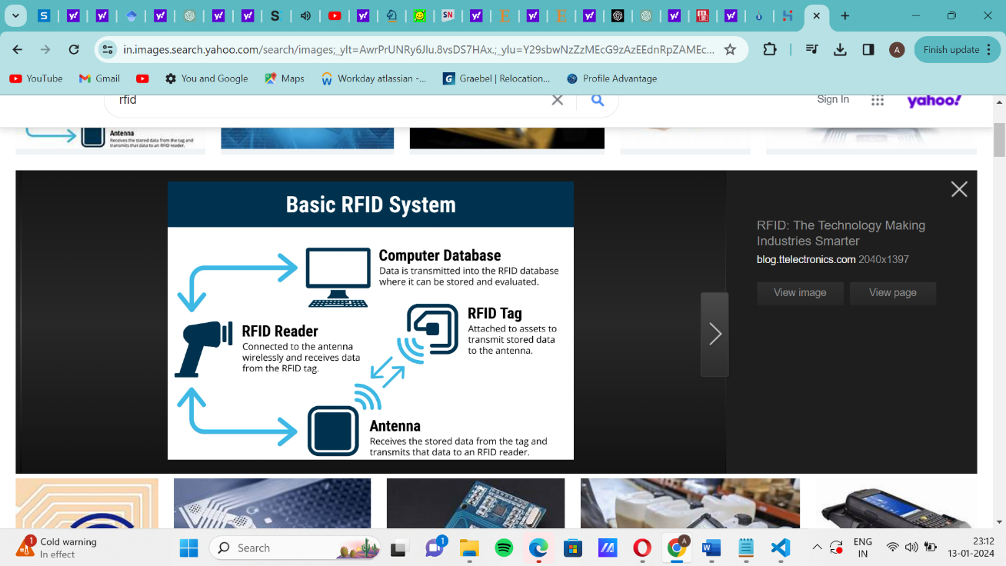

* **Blockchain without QR Codes**: Relying on blockchain technology for product traceability and authenticity verification without the user-friendly aspect of QR codes.
* **Colorimetric and fluorometric approaches:** It offers simplicity, cost-effectiveness, sensitivity, quantitative analysis, and applicability in diverse concentrations, ensuring reliable counterfeit detection
* **Physical Authentication Marks**: Using physical authentication marks like embossed logos or seals on products, which may not provide real-time validation.
* **Consumer Feedback Alone**: Relying solely on consumer reviews and feedback as a means of counterfeit detection without a systematic technological verification system.
* **Magnetic Stripes**: Implementing magnetic stripes on products for authentication, which can be less secure and easier to replicate than digital methods like QR codes.
* **Offline Verification Centers**: Establishing physical verification centers that consumers need to visit in person for product authentication, which is less convenient and accessible.
* **Security Labels**: Using security labels or stickers on products for authentication, which may not provide the same level of convenience as QR code scanning.

**2.5. Proposed Methodology**

In this “COUNTERFEIT DETECTION SYSTEM”, we will be having a QR code associated with the unique ID of product where while scanning, it will show various details about the company and the all the necessary information like whether the product is sold before or not, manufacturing place, manufacturer name, etc.

The proposed Counterfeit Detection System presents a holistic strategy for addressing counterfeit products by utilizing QR code technology.

In the initial stages, the system requires the precise input of product details into the QR code system. This includes crucial information such as the company name, product specifications, available sizes, color variations, and pricing. This detailed data aims to empower consumers, helping them make well-informed purchasing decisions and choose the right products.

Following this, the distribution process begins as companies sell their products to retailers, each item tagged with a unique product ID for easy tracking. Retailers then sell these products to consumers at prices determined by the company, promoting transparency and accountability in sales.

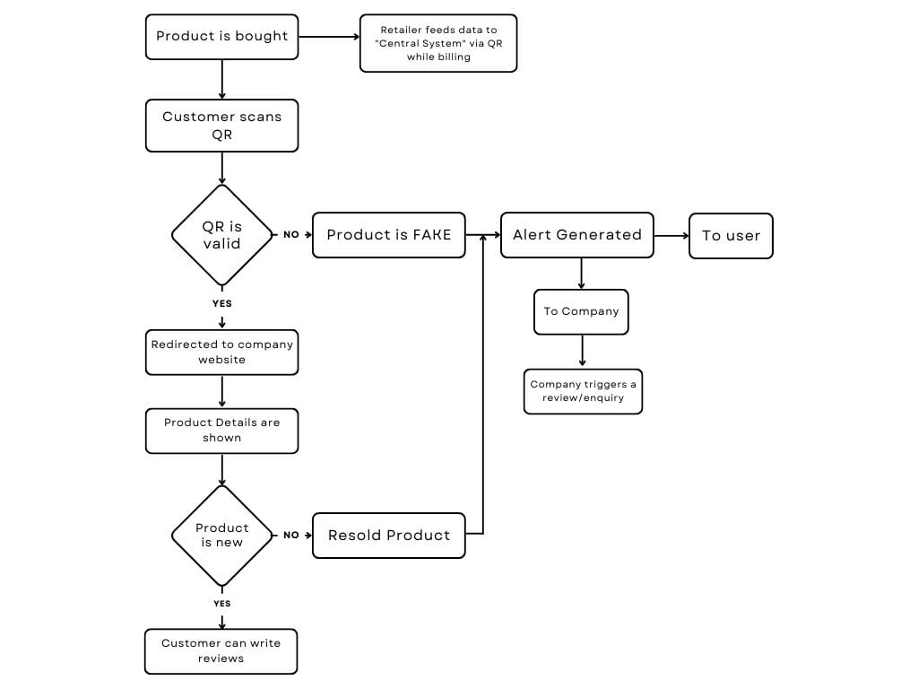When consumers buy products, they can scan the QR codes to access real-time product information. If an invalid QR code is detected, an automatic alert notifies the company, leading to investigations and actions against non-compliant retailers. On the other hand, valid QR code scans allow consumers to leave reviews, encouraging consumer engagement and deterring counterfeit product reproduction.

Overall, this robust system, supported by QR code technology, serves as a strong defence mechanism, ensuring product authenticity and fostering consumer trust in reputable brands for a safer and more transparent shopping experience.

Here's how the Counterfeit Detection System works:

1. A screenshot of a computer

   Description automatically generated**QR Code Scanning**: As consumers prepare to make a purchase, they encounter a crucial checkpoint—the QR code affixed to the product. With a quick scan using their mobile devices, they initiate the process.
2. **Validation and Product Details:** The system springs into action, rigorously validating the QR code's authenticity. If the QR code checks out as genuine, users are seamlessly redirected to the official website of the brand, where a wealth of essential product details awaits. These details include a stamp of authenticity from the brand, the original price of the product, its current sold status, and insights into its supply chain journey.

1. **Informed Decision-Making**: Armed with this valuable information, consumers are empowered to make informed decisions about their purchase. If the product is confirmed as new and unsold, they can proceed with confidence, knowing they are acquiring an authentic item. On the other hand, if the QR code raises any doubts or the product has been resold, the system triggers an alert, both to the user and the concerned brand. This proactive approach serves as a powerful deterrent to counterfeit activity.

Company End:

**2.6. DATASETS AND INPUTS**

Throughout the entire process, we're using our carefully created dataset.

**Phase 1:**

**Inputs**: Information about the product (company name, brand name, characteristics, size, color, price, etc.)

**Output**: Encoding of the product details into a QR code

**Phase 2:**

**Inputs**: Product with a unique product ID

**Output**: Sale of the product to the retailer.

**Phase 3:**

**Inputs**: Consumer scanning the QR code

**Output**: Display of product details to the consumer.

**Phase 4:**

**Inputs**: Invalid QR code or product status indicating it has been sold before

**Output**: Alert generation to the company, retailer inquiry initiated, potential actions against the retailer. **Phase 5:**

**Inputs**: Valid QR code

**Output**: Consumer ability to write product reviews, check against replication of branded products

**3. CONCLUSION**

The proposed Counterfeit Detection System, centered around QR code technology, serves as a safeguard against counterfeit products. It empowers consumers to make informed purchasing decisions by providing real-time authentication and product information. By leveraging the strength of QR codes, consumers can easily verify the authenticity of clothing products, thereby ensuring their safety and protecting their trust in legitimate brands.

**4. FUTURE SCOPE**

The future scope of the counterfeit detection system includes integrating machine learning to improve the accuracy and efficiency of product authentication, expanding to cover various industries, implementing real-time monitoring and tracking, fostering partnerships with government agencies and industry associations, and developing user-friendly mobile applications for instant authentication. These advancements will enhance the system's effectiveness in combating counterfeiting and protecting consumers and businesses.

**5. REFERENCES**

[[1] Tiwari, S. (2016). "An introduction to QR code technology." In 2016 International Conference on Information Technology (ICIT). Department of Technical Education, SITS Educators Society, Jabalpur, Madhya Pradesh, India.](https://ieeexplore.ieee.org/document/7966807)

[[2] Patel, A. K., & Singh, A. (2018). "A STUDY ON COUNTERFEIT BRANDS, CONSUMER ATTITUDE AND INITIATIVES TO STOP COUNTERFEITING IN INDIA." AD VALOREM - Journal of Law, 5(II), April - June 2018, ISSN: 2348-5485.](https://www.researchgate.net/publication/356085681_A_STUDY_ON_COUNTERFEIT_BRANDS_CONSUMER_ATTITUDE_AND_INITIATIVES_TO_STOP_COUNTERFEITING_IN_INDIA)

[[3] Picard, J., Landry, P., & Bolay, M. (2021). "Counterfeit detection with QR codes." In Proceedings of the 21st ACM Symposium on Document Engineering.](https://dl.acm.org/doi/10.1145/3469096.3474924)

[[4] Pio, L., Cavaliere, L. P. L., Mangalasserri, K., Venkateswaran, P. S., Byloppilly, R., Effendy, F., More, A., Rajest, S., & Rajan, R. (2021). "THE IMPACT OF BRAND COUNTERFEITING ON CONSUMER BEHAVIOR IN THE FASHION SECTOR."](https://www.researchgate.net/publication/355041587_THE_IMPACT_OF_BRAND_COUNTERFEITING_ON_CONSUMER_BEHAVIOR_IN_THE_FASHION_SECTOR)

[[5] Staake, T., Thiesse, F., & Fleisch, E. (2004). "Extending the EPC Network – The Potential of RFID in AntiCounterfeiting." Report No. 27, October 20, 2004. Authors: Thorsten Staake, Frederic Thiesse, Elgar Fleisch.](https://www.researchgate.net/publication/236647561_Extending_the_EPC_network_-_The_potential_of_RFID_in_anti-counterfeiting)

[[6] International Chamber of Commerce. (2016). "The Economic Impacts of Counterfeiting and Piracy."](https://iccwbo.org/wp-content/uploads/sites/3/2017/02/ICC-BASCAP-Frontier-report-2016-Executive-Summary.pdf)

[[7] Daoud, E., Vu, D., Nguyen, H., & Gaedke, M. (2020). "IMPROVING FAKE PRODUCT DETECTION USING AI-BASED TECHNOLOGY.”](https://www.researchgate.net/publication/339983307_IMPROVING_FAKE_PRODUCT_DETECTION_USING_AI-_BASED_TECHNOLOGY)

[[8] Yoon, B., Lee, J., Park, I. S., Jeon, S., Lee, J., & Kim, J. M. (2013). "Recent functional material based approaches to prevent and detect counterfeiting."](https://pubs.rsc.org/en/content/articlelanding/2013/tc/c3tc00818e)

[[9] Wasnik, K., Sondawle, I., Wani, R., & Pulgam, N. (2022). "Detection of Counterfeit Product using Blockchain."](https://www.itm-conferences.org/articles/itmconf/pdf/2022/04/itmconf_icacc2022_03015.pdf)

[[10] Guin, U., DiMase, D., & Tehranipoor, M. (2014). "Counterfeit Integrated Circuits: Detection, Avoidance, and the Challenges Ahead."](https://link.springer.com/article/10.1007/s10836-013-5430-8)

[[11] Horn, C., Blankenburg, M., Fechteler, M., & Kruger, J. (2013). "Product Piracy Prevention: Product Counterfeit Detection Without Security Labels."](https://go.gale.com/ps/i.do?id=GALE%7CA353645958&sid=googleScholar&v=2.1&it=r&linkaccess=abs&issn=23050012&p=AONE&sw=w&userGroupName=anon%7E68e5e571&aty=open-web-entry)

[[12] Choi, S. H., & Poon, C. H. (2007). "An RFID-based Anti-counterfeiting System."](https://www.iaeng.org/publication/WCE2007/WCE2007_pp1082-1087.pdf)-